IIS Documentation

1. Set up internet information services by enabling it in **Control panel>Programs>Programs and features> Turn windows features on and off.** Check all tickboxes for Internet information services.

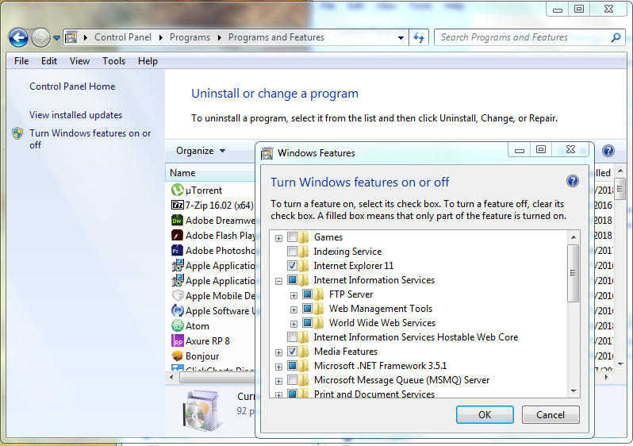

1. After enabling, open the iis manager from the windows menu

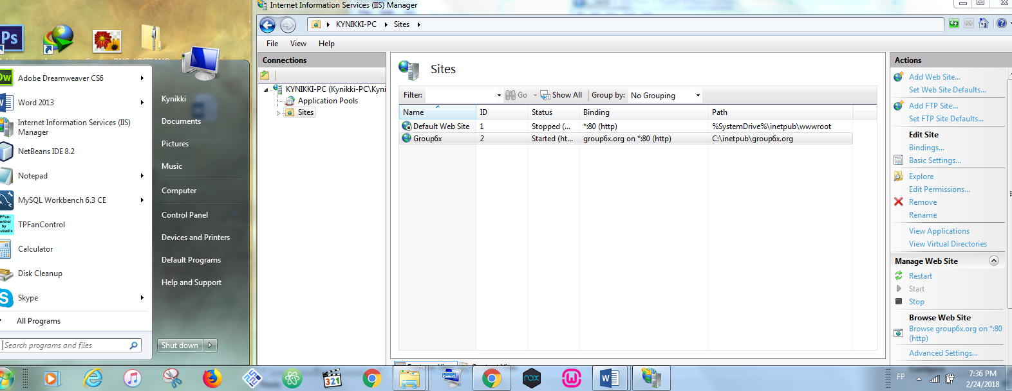

1. Add a website by right clicking on the sites list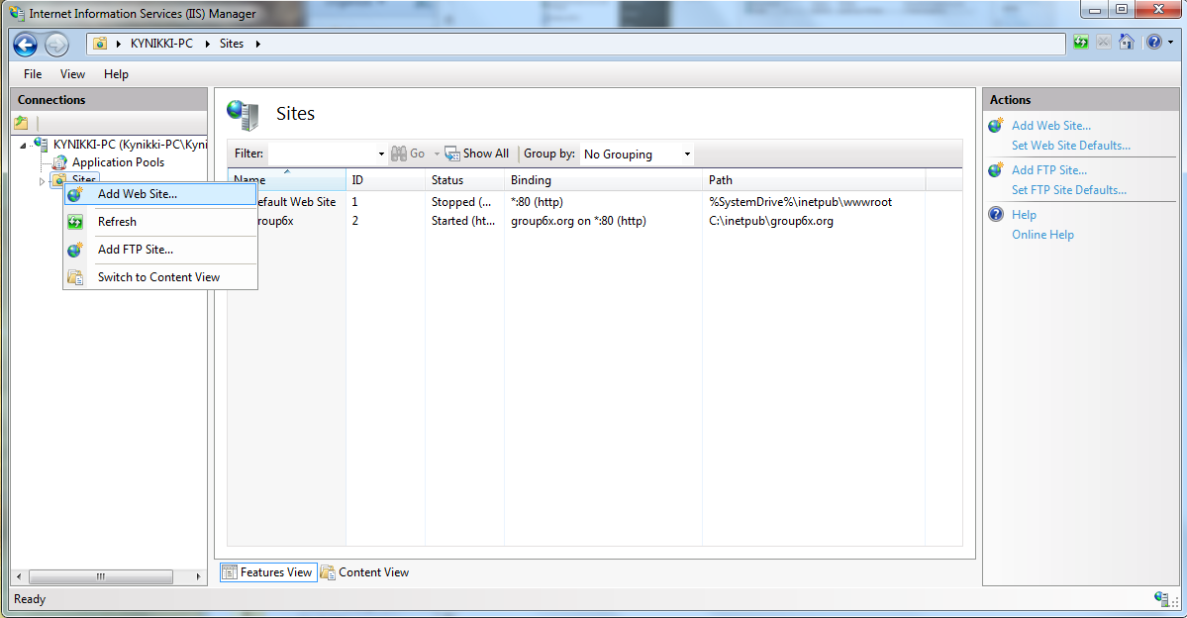
2. After clicking add websiteAdd website by placing website name, directory of the website, and host name and add the website name to the hosts file in windows

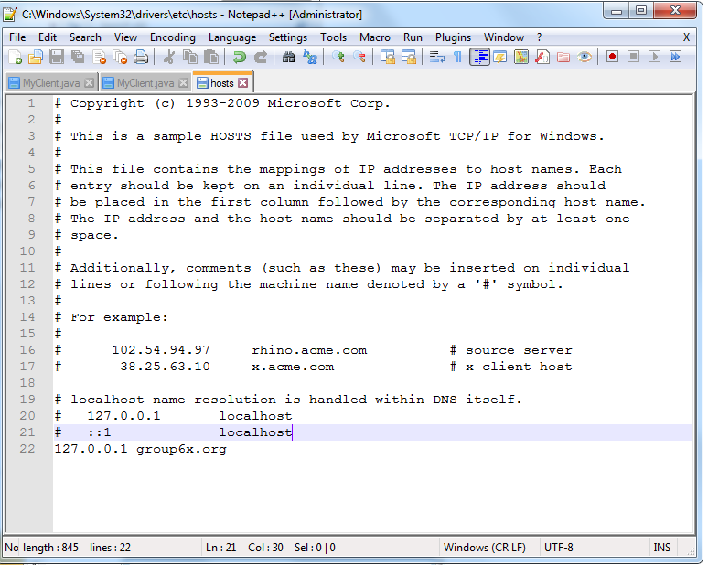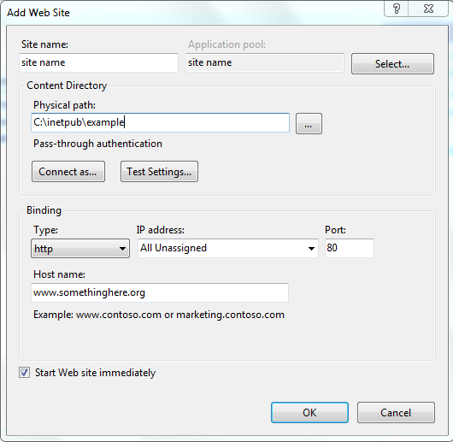

1. If the website folder was successfully added without anything inside it will show this website when tested on a browser.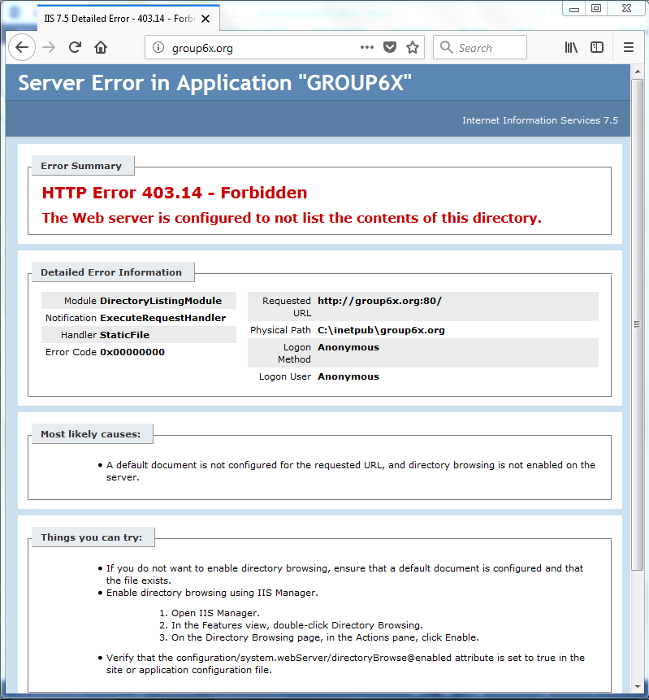
2. Next add the files to the folder if it was not yet added. Or if it was, set the default document in the IIS namely index.html. Use the homepage as the highest priority in the list.

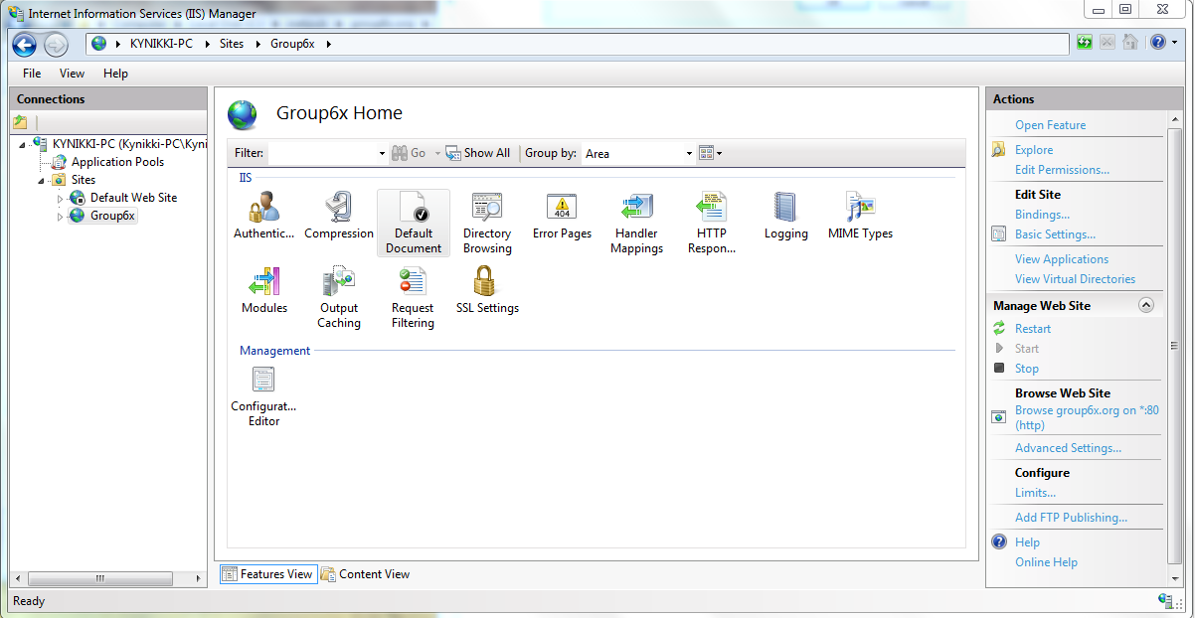

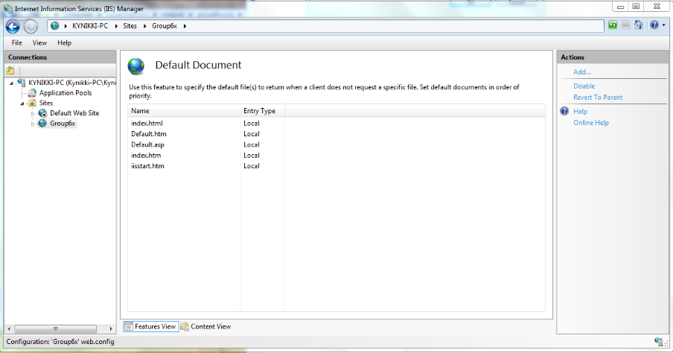

1. The website shall now show up in a browsers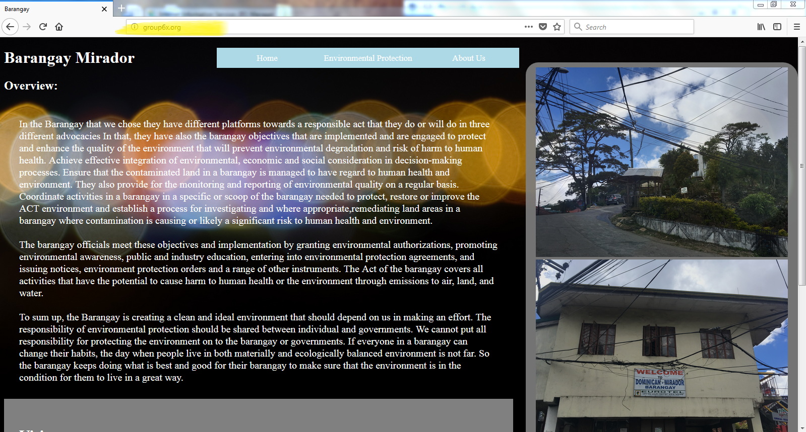
2. Next Configure compression by going to **windowsdirectory\Windows32\Inetsrv\config** and edit **applicationHost.config** . Search for <httpCompression> and edit the fields under it to limit compression to html and css

